**Task mistake search**

**1. The screenshot in README.md do not match in project**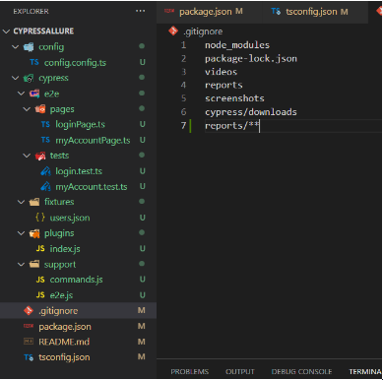

**Screenshot in project**

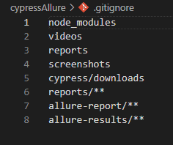

**2. Don’t need to use container in container**

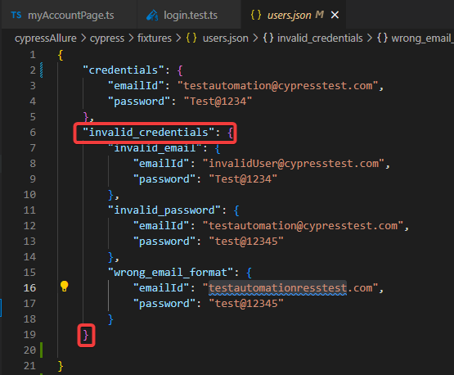

**3.1 You don't need to include the POM if you don't use it in your code**

**3.2** **Using "beforeEach" if we have a single "it" block is not appropriate**

**3.3 There should be no commented text in the finished versions of the test cases**

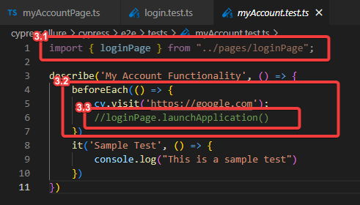

**4. Error in the assertion element because we have a mistake in a string on the picture below**

'Invalid email addressssss.'

**To correct the work test, you need to change the string to** 'Invalid email address.'

 **Saw this error in the allure report**

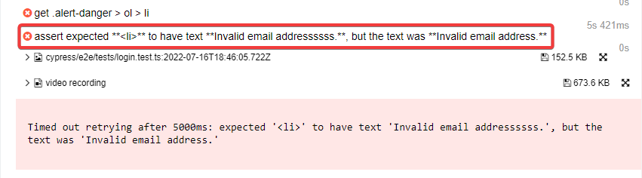

**5. In pages loginPage.ts and myAccountPage.ts use should(), always need to use should() in the test case**

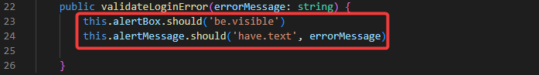



**6. This elements in the code don't have camelCase** 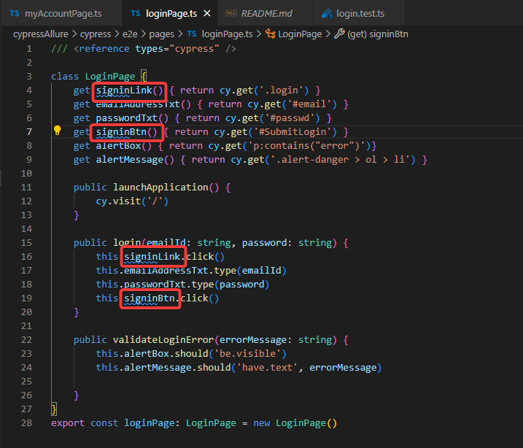

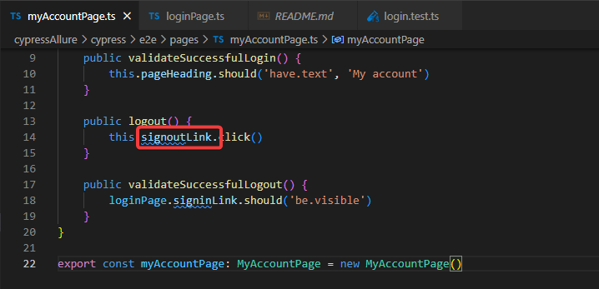

**7. Mistake in steps to run project**

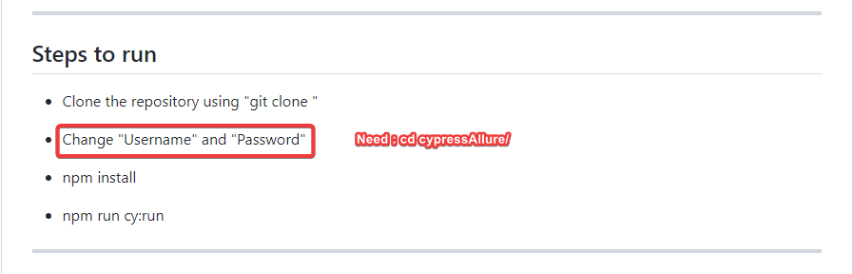

**Repository Link:** https://github.com/AZANIR/cypressAllure